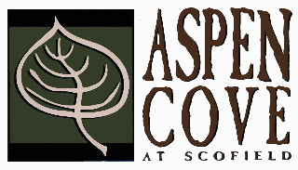

UPCOMING EVENT
TUESDAY JUNE 2ND AND WEDNESDAY JUNE 3RD
ROADS WILL BE CLOSED FOR DUST CONTROL
PLEASE PLAN ACCORDINGLY
QUESTIONS PLEASE CONTACT THE BOARD AT ASPENCOVEHOA.ORG

